**JUNIPER-CISCO MP-BGP LAB**

**Network Topology:**

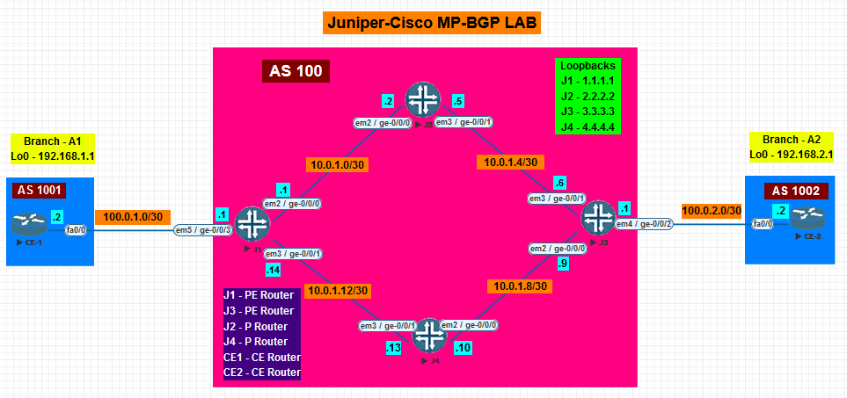

**NOTE: Perform All the basic factory-default, root password and System hostname configuration on Juniper Router before performing the lab. (Given in Static Routing Lab)**

1. **Configure the respective physical interfaces & also configure the loopback interfaces on all the routers in the configuration mode as per the network topology**

**CISCO Routers:  
C1: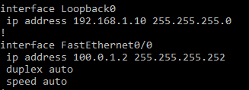 C2:**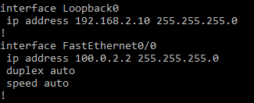

**JUNIPER Routers:  
J1: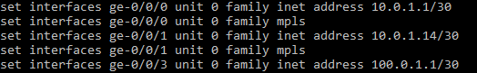 J2: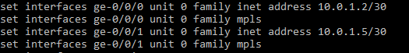 J3: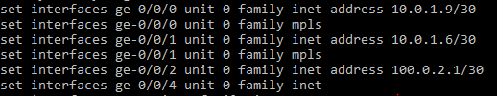 J4:**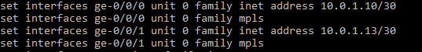

1. **Verify using the show command that all the interfaces are configured correctly**

**CISCO Routers:  
C1: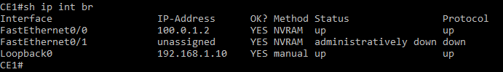 C2:**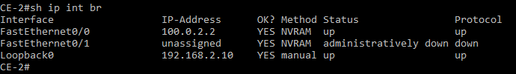

**JUNIPER Routers:  
J1: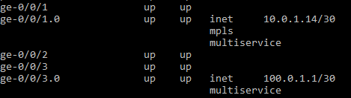 J2:**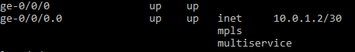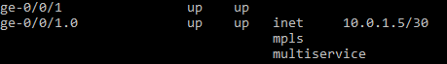

**J3:**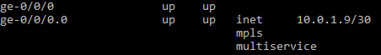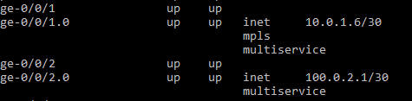

**J4:**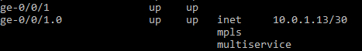

1. **Configure OSPF on all the Provider routers present in AS 100.**

**JUNIPER Routers:  
J1:** **J2:** **J3:** **J4:**

1. **Verify OSPF neighborship for all Provider routers present in AS 100.**

**JUNIPER Routers:  
J1: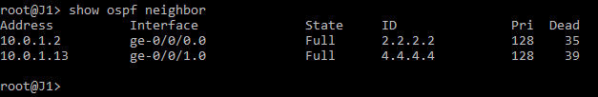 J2: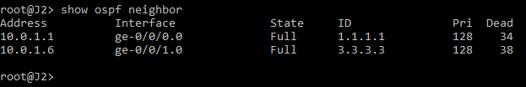 J3: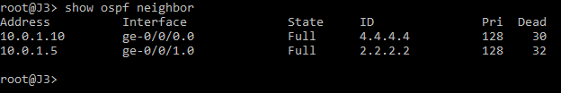 J4:**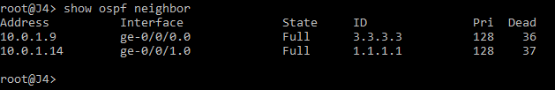

1. **Configure MPLS on all the Provider routers present in AS 100. Also enable mpls on the interfaces.**

**JUNIPER Routers:  
J1:** **J2:** **J3:** **J4:**

1. **Verify MPLS neighborship for all Provider routers present in AS 100.**

**JUNIPER Routers:  
J1: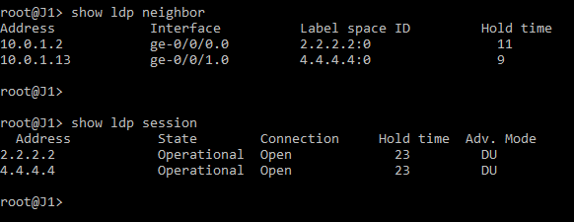 J2: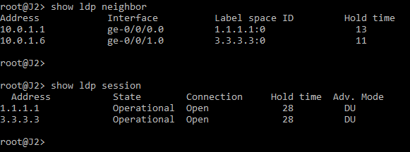 J3: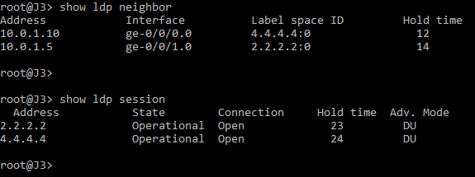 J4:**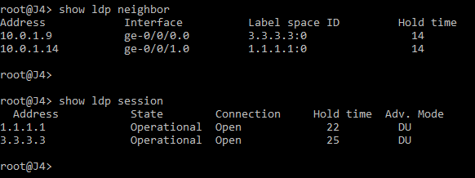

1. **Verify LDP database for all Provider routers present in AS 100.**

**JUNIPER Routers:  
J1: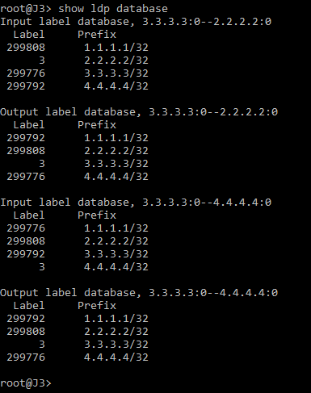 J2:**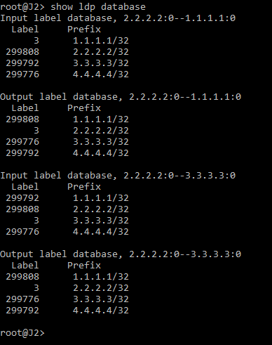

**J3: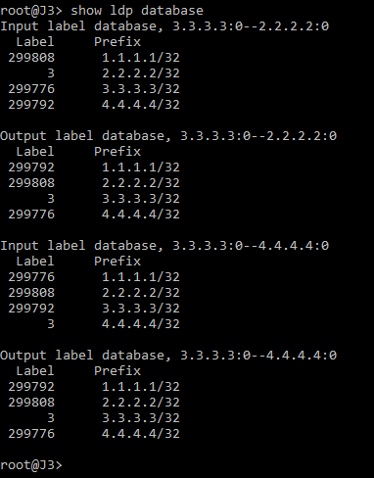 J4:**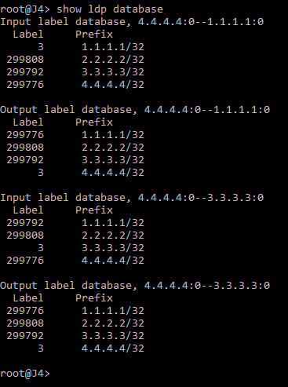

1. **Check connectivity between both PE routers. (Lo0 should be able to ping)**

**JUNIPER Routers:  
J1: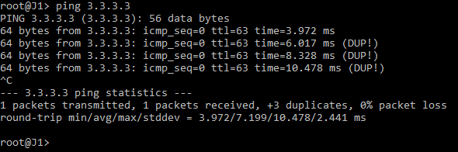 J3:**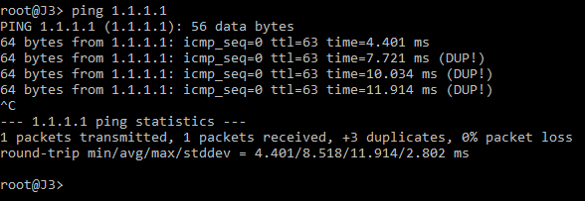

1. **Configure VRF instances on PE routers J1 and J3. Also configure RD and RT values to send VRF VPN routes. Enable VRF on the external interfaces of PE routers pointing towards CE routers.**

**JUNIPER Routers:  
J1: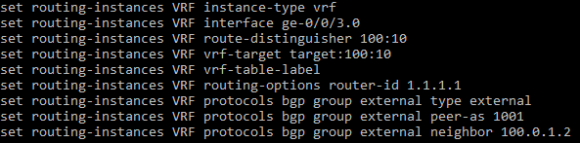 J3:**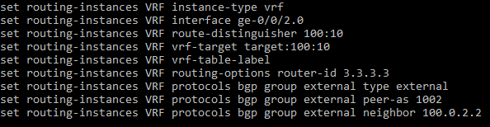

1. **Verify the configuration of VRF**

**JUNIPER Routers:  
J1: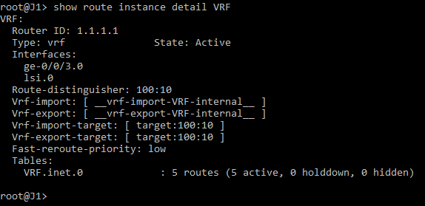 J3:**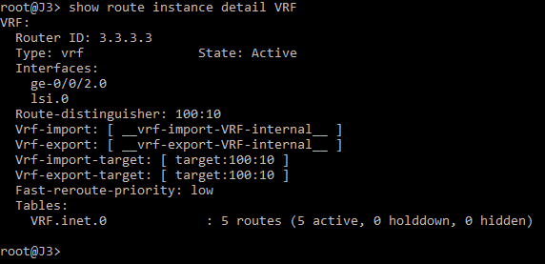

1. **Configure IBGP between PE routers.**

**JUNIPER Routers:  
J1: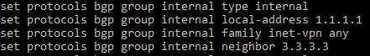 J3:**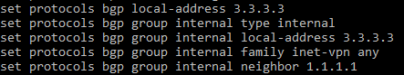

1. **Configure EBGP between PE and CE routers at both end.**

**CISCO Routers:  
C1: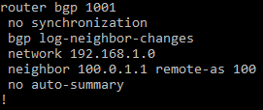 C2:**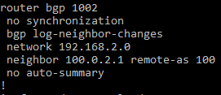

**JUNIPER Routers:  
J1: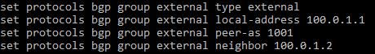 J3:**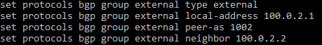

1. **Verify IBGP neighborship between PE routers and EBGP between PE and CE routers.**

**CISCO Routers:  
C1: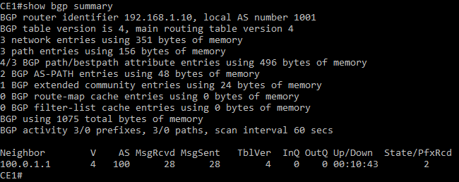 C2:**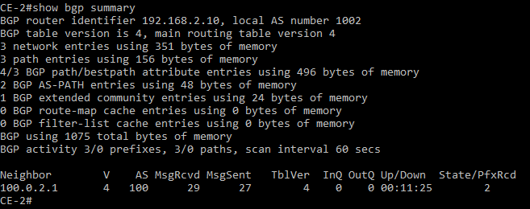

**JUNIPER Routers:  
J1: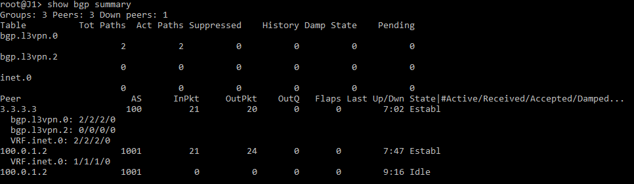 J3:**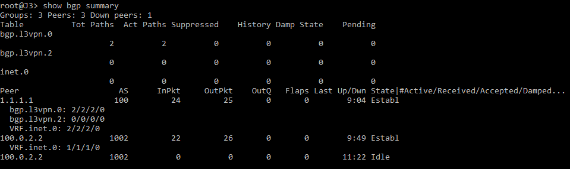

1. **Verify connectivity between respective PE and CE routers.**

**CISCO Routers:  
C1: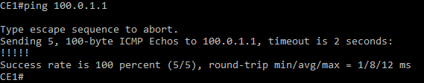 C2:**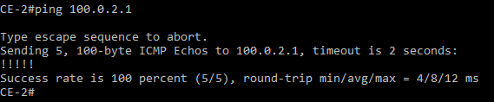

**JUNIPER Routers:  
J1: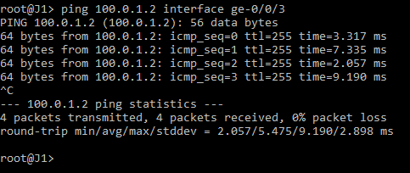 J3:**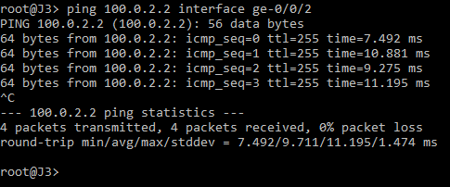

1. **Verify routing tables on all the routers**

**CISCO Routers:  
C1:**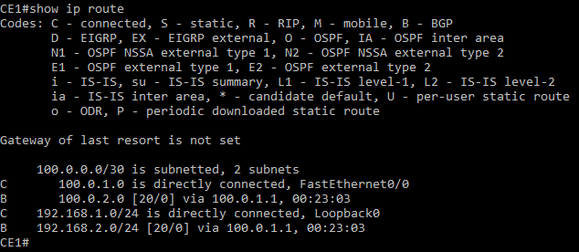

**C2:**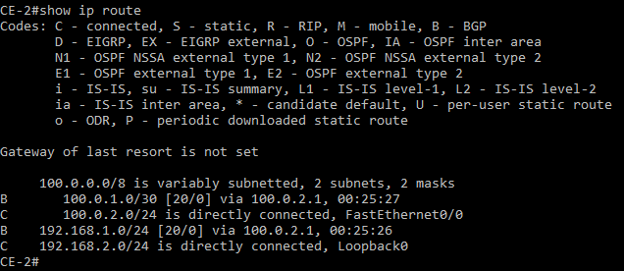

**JUNIPER Routers:  
J1:**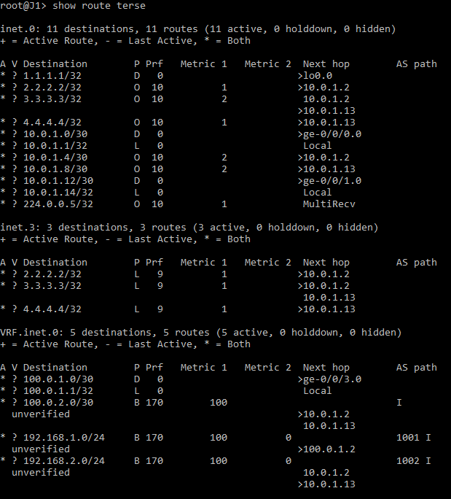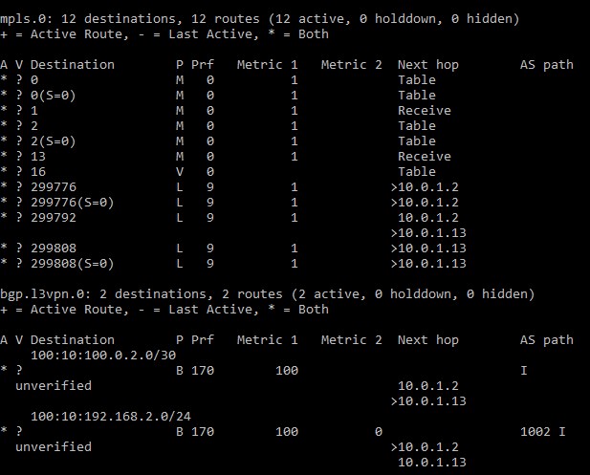

**J3:**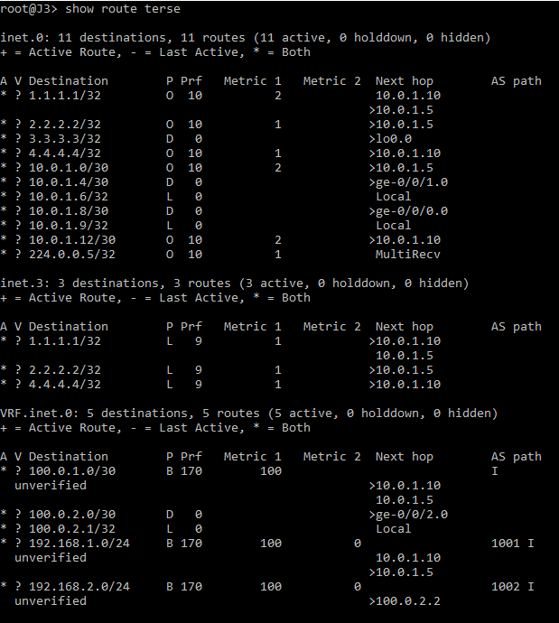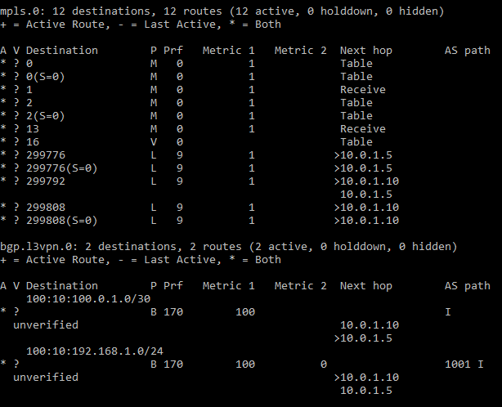

**J2: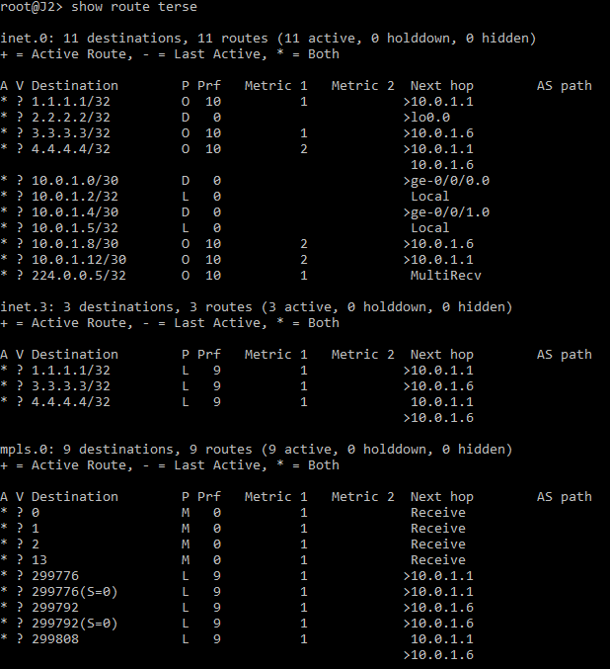 J4:**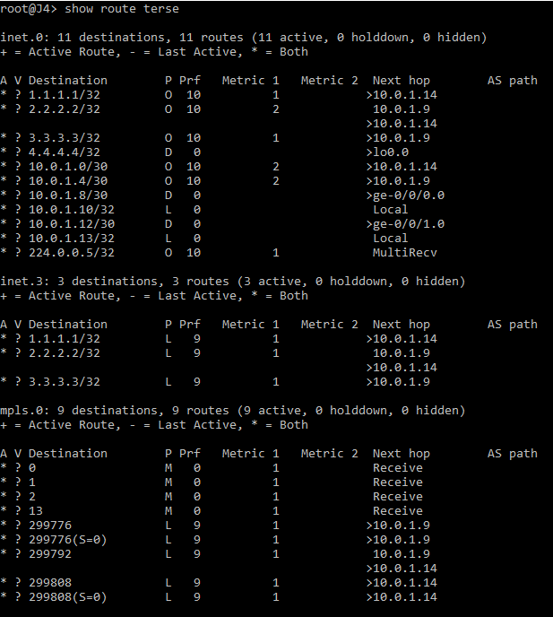

1. **Verify end to end connectivity between CE routers.**

**CISCO Routers:  
C1: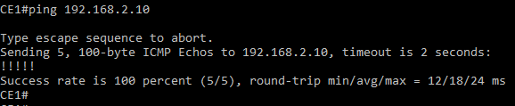 C2:**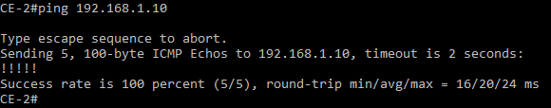

1. **Attach Screenshot of configuration commands on Juniper routers.**

**JUNIPER Routers:  
J1:**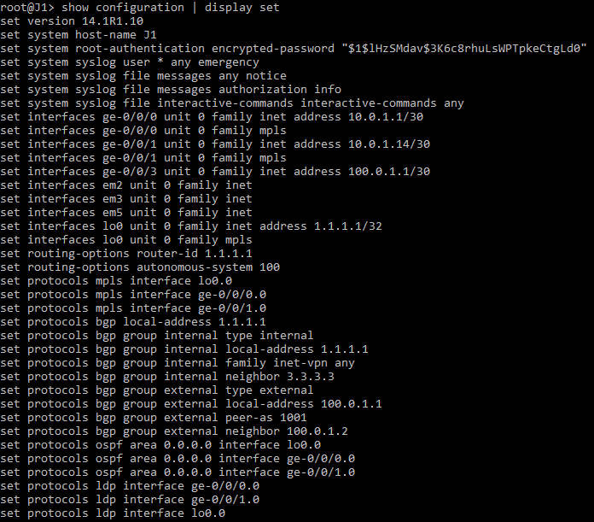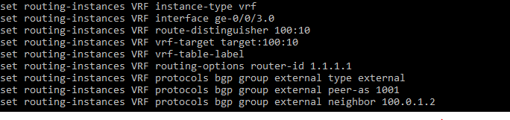

**J3:**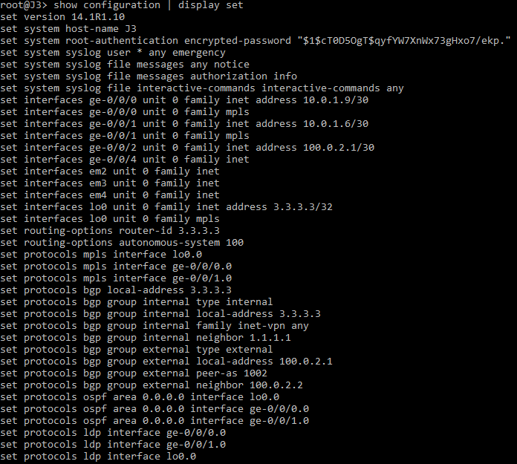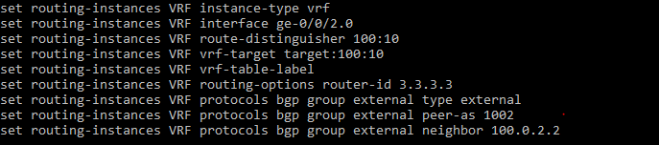

**J2: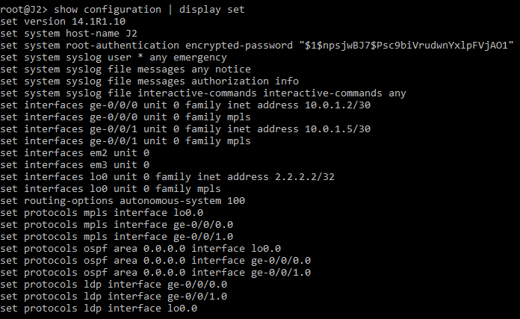 J4:**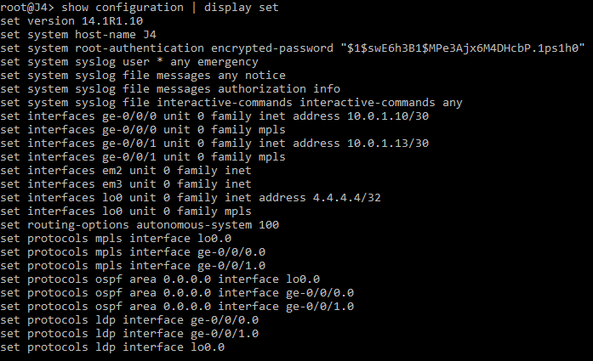

1. **Attach screenshot of show configuration.**

**CISCO Routers:  
C1:**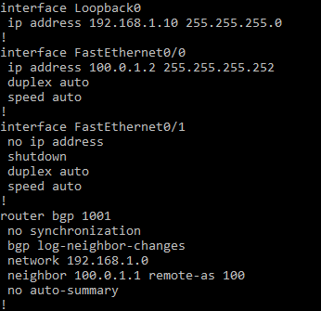

**JUNIPER Routers:  
J1:**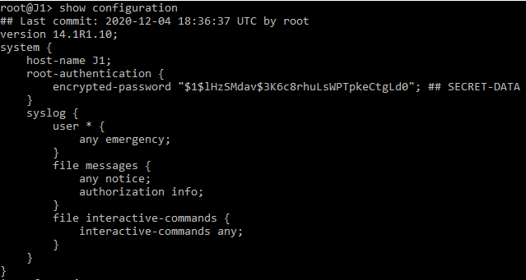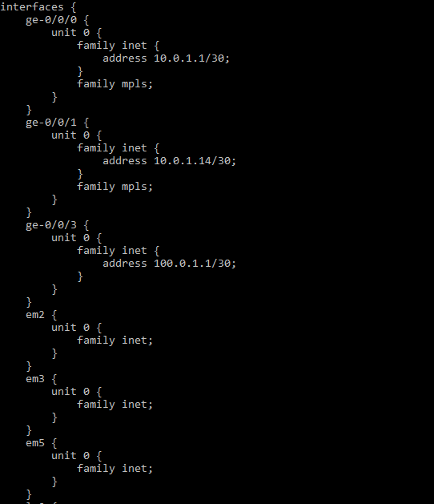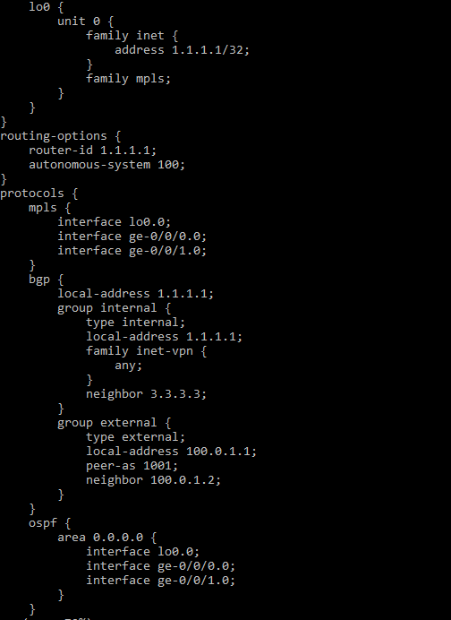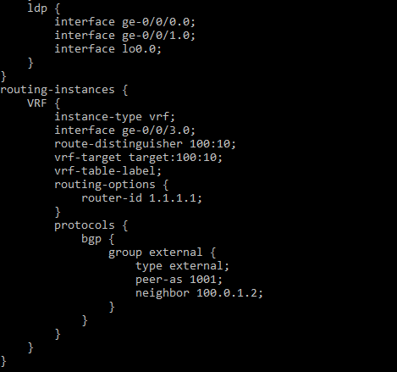

1. **Attach screenshot of Routing Instances on PE routers.**

**JUNIPER Routers:**

**J1: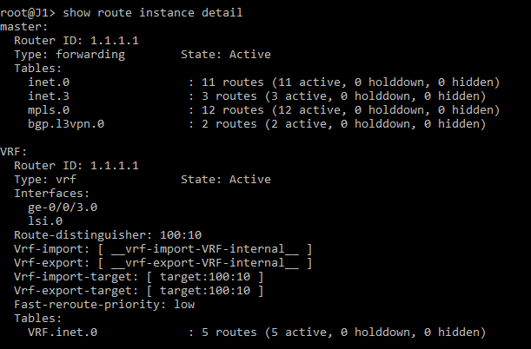 J3:**